FINAL PROJECT THE MIXTAPE
a multimodal/creative project assignment

WHAT'S A MIXTAPE?
CASSETTE TAPE OR OTHER MEDIUM
BY AN INDIVIDUAL.
A COMPILATION OF FAVORITE PIECES

OF MUSIC, TYPICALLY BY DIFFERENT
ARTISTS, RECORDED ONTO A

SELECT ANY (1) READING FROM THE ASSIGNMENTCONNECT THE READING TO MUSIC
WHAT'S THESEMESTER

FROM THE SAME ERA
Make a YouTube Playlist. Essentially you are creating a "Soundtrack" for the reading from start to finish.

COMPOSE 2 - 4 PAGES OF LINER NOTES
This will provide context and explanation for the pairing of each song to the reading.

COMPLETE YOUR "ALBUM"
Select artwork or photography from the period to grace the cover of your mixtape.

SELECT A READING
CONSIDER THE ELEMENTS OF THE STORY
The reading you select is the inspiration behind your Mixtape.
What Is the Setting? Time / Place.
The Plot: Intro, Rising Action, Climax, Falling Action, Denouement What is the Conflict?
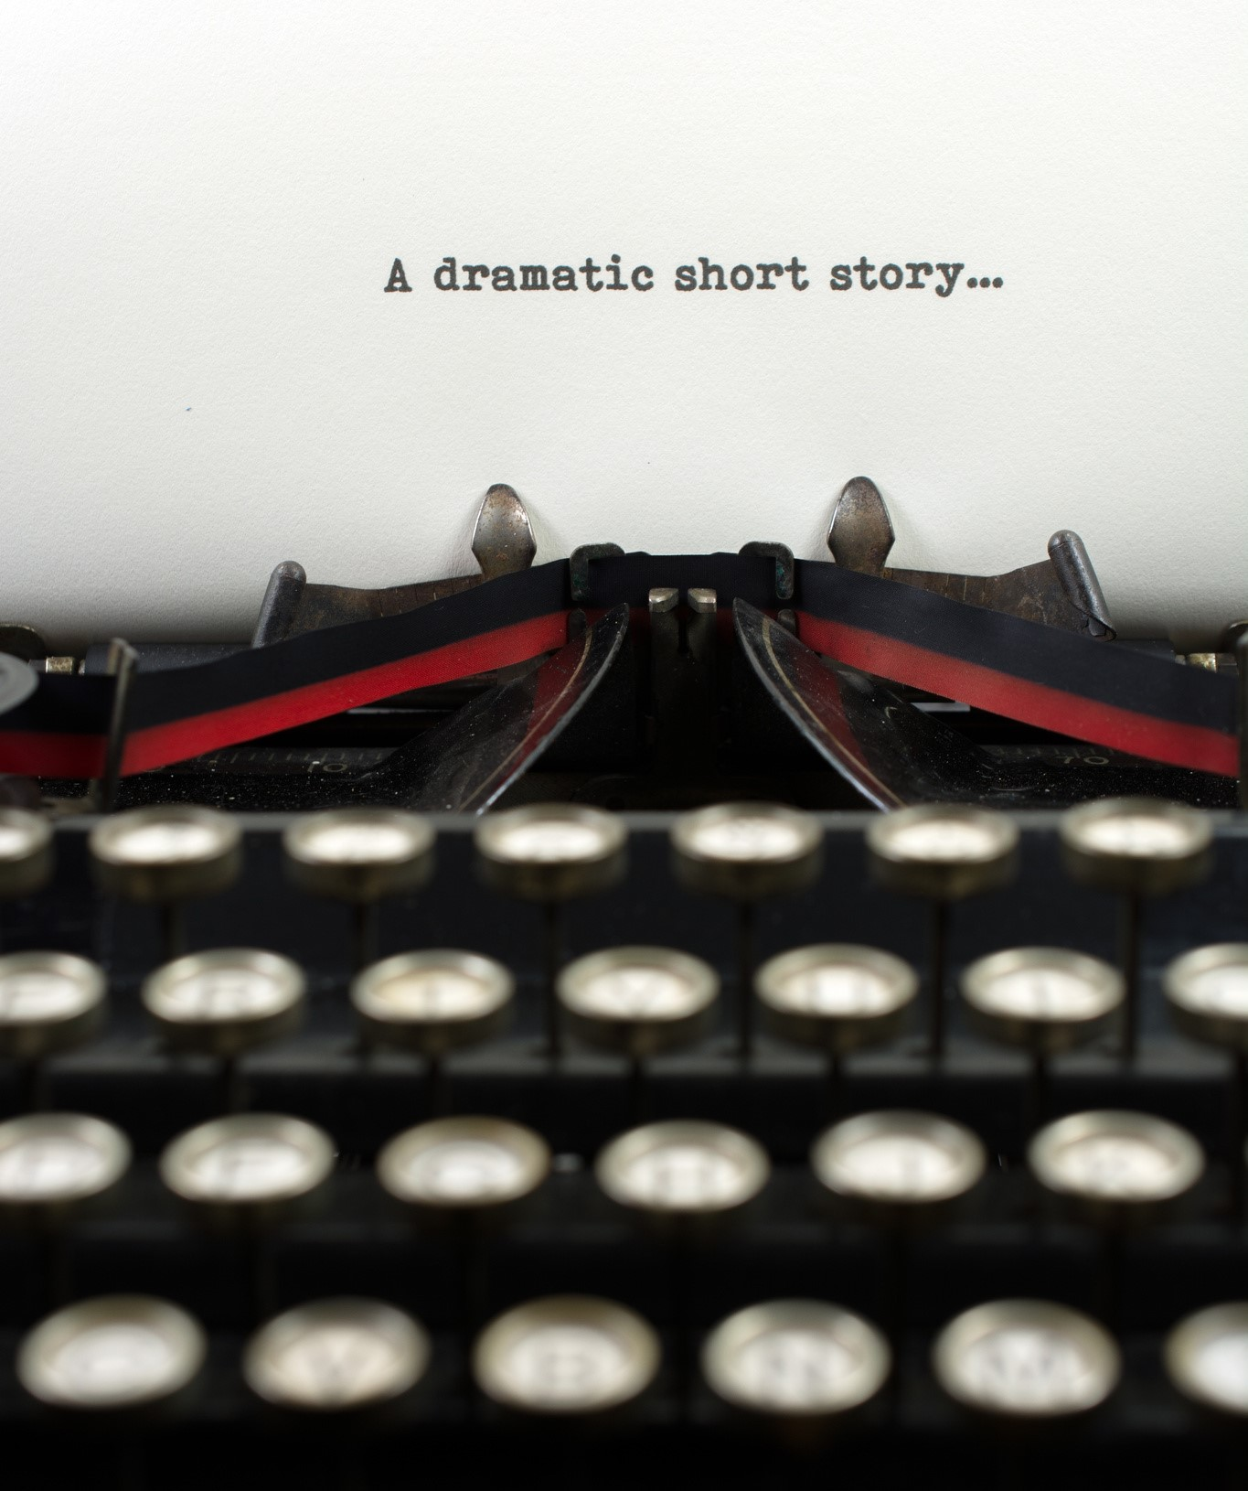
Character
Point of View - Who is the narrator? Theme
AFTER CONSIDERING THE ELEMENTS OF THE
CONNECT THE READING, WHAT SONGS COME TO MIND?
READING TO The elements should align with your music selection.
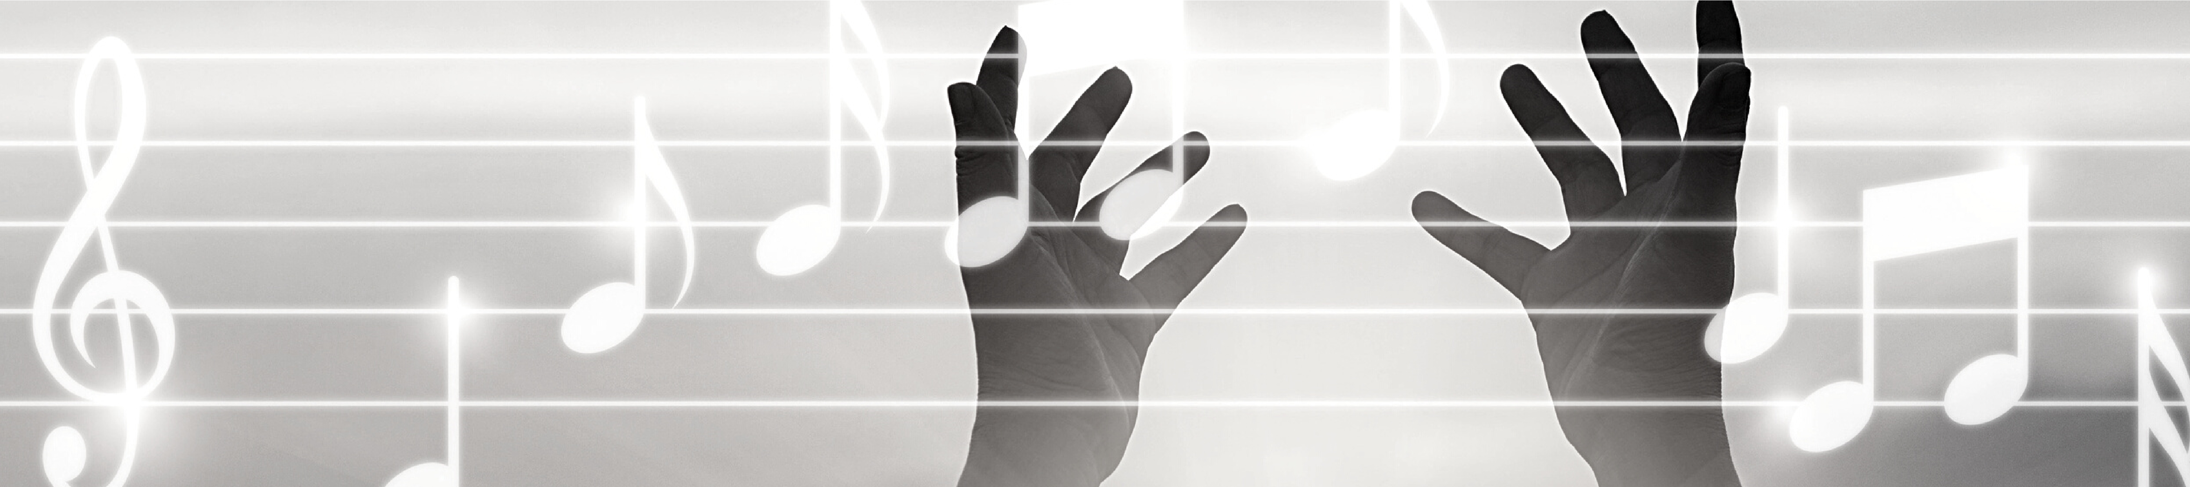
This assignment requires a minimum of 6 song
character / tone / mood.
MUSIC selections.
Arrange songs in your YouTube Playlist based on the story. The songs you select should follow the plot /

WHAT ARE LINER NOTES?
HTTPS://WWW.THEBALANCECAREERS.COM/LINER-NOTES-2460592
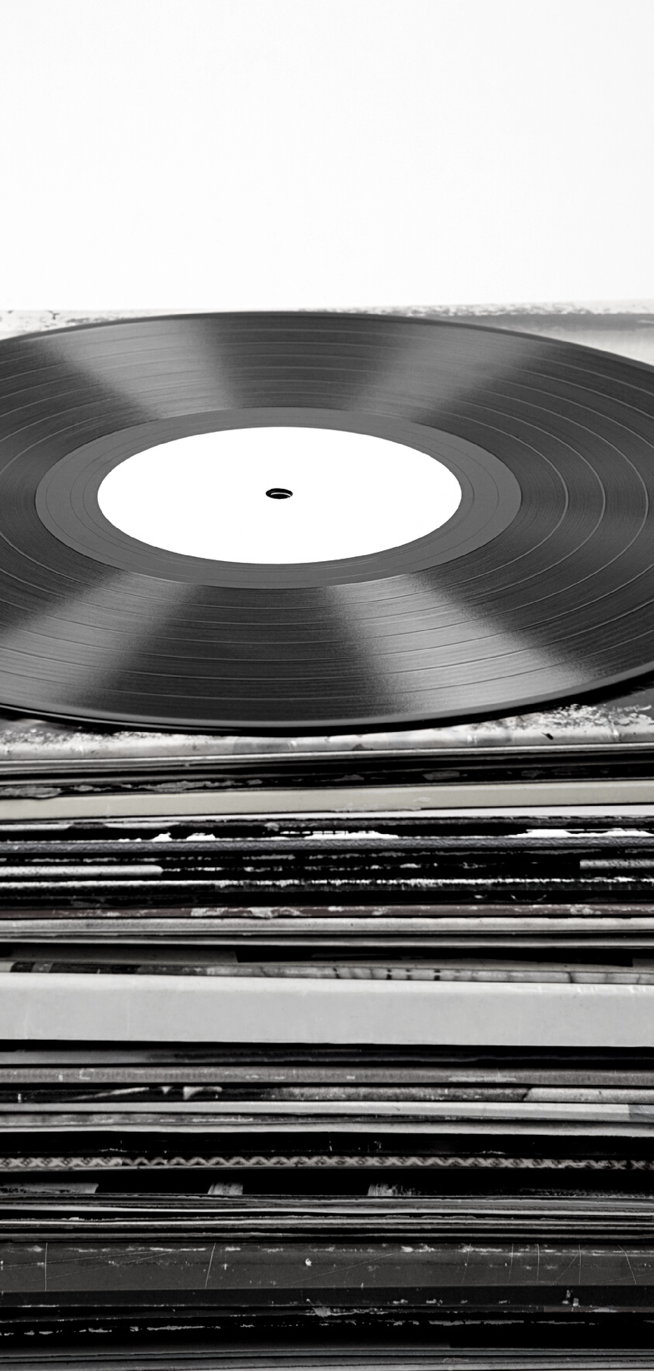
"...editorial narratives continued on the album's liner—the protective cover that slipped inside the LP cover. Eventually, the practice adopted as liner notes grew longer so that eventually most of the written comments appeared not on the back cover but on the album's liner, hence "liner notes." These notes contain information about the record— credits for everyone involved in the recording, information about the record label putting out the record, copyright information, and sometimes, song lyrics—as well as growing editorial content peripherally related to the music."
(see examples on next two slides)
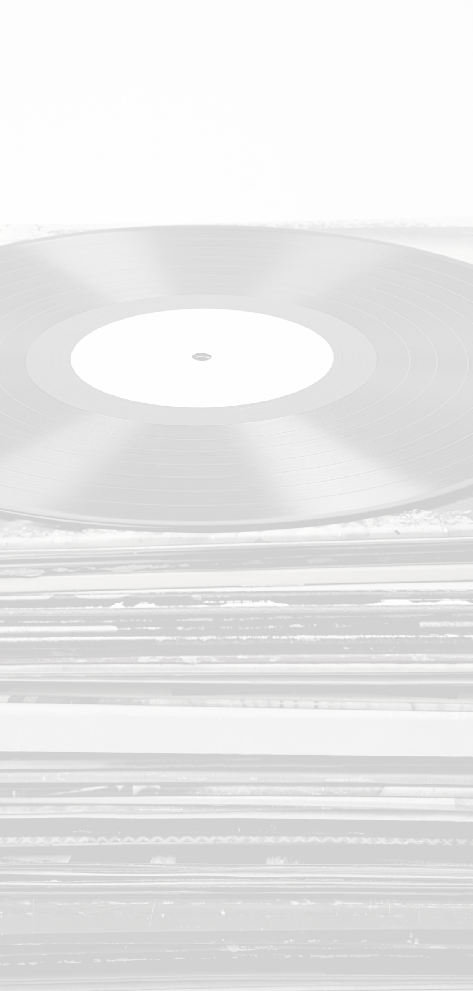
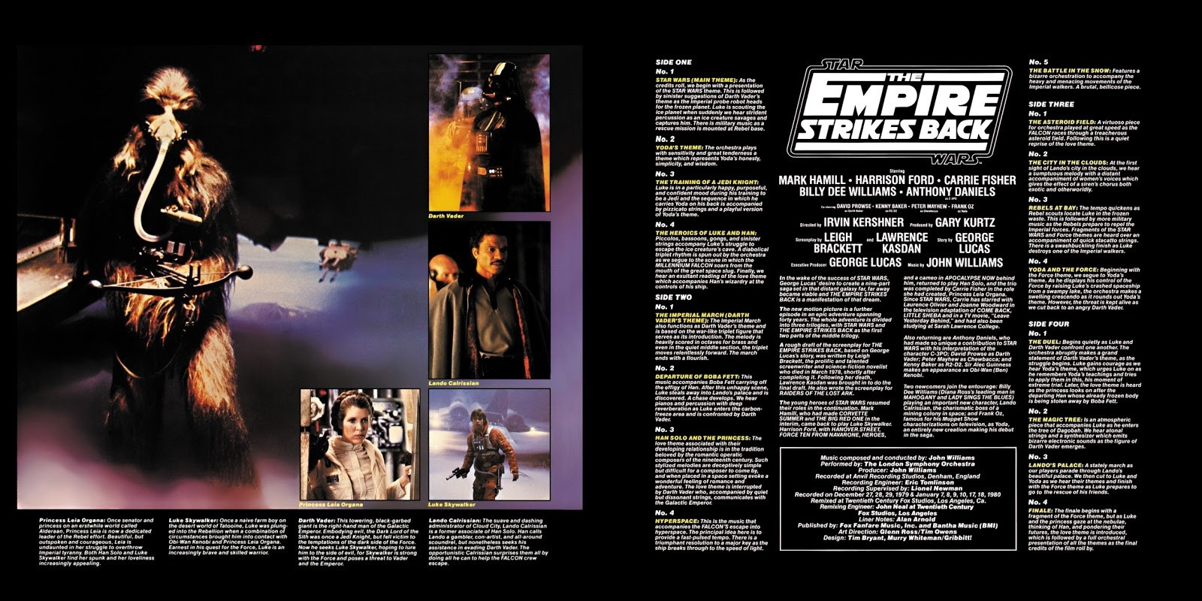
EXAMPLE
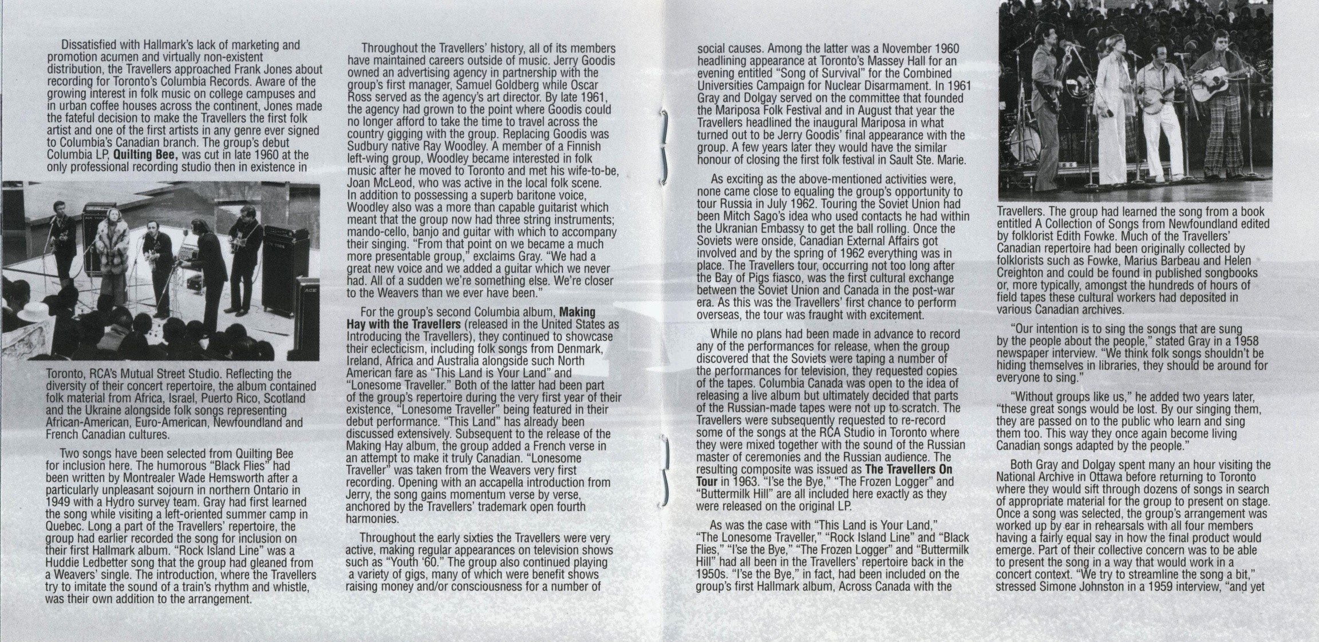
EXAMPLE

YOUR LINER NOTES
This is the written part of your assignment. You will compose 2 to 4 pages of Liner Notes.
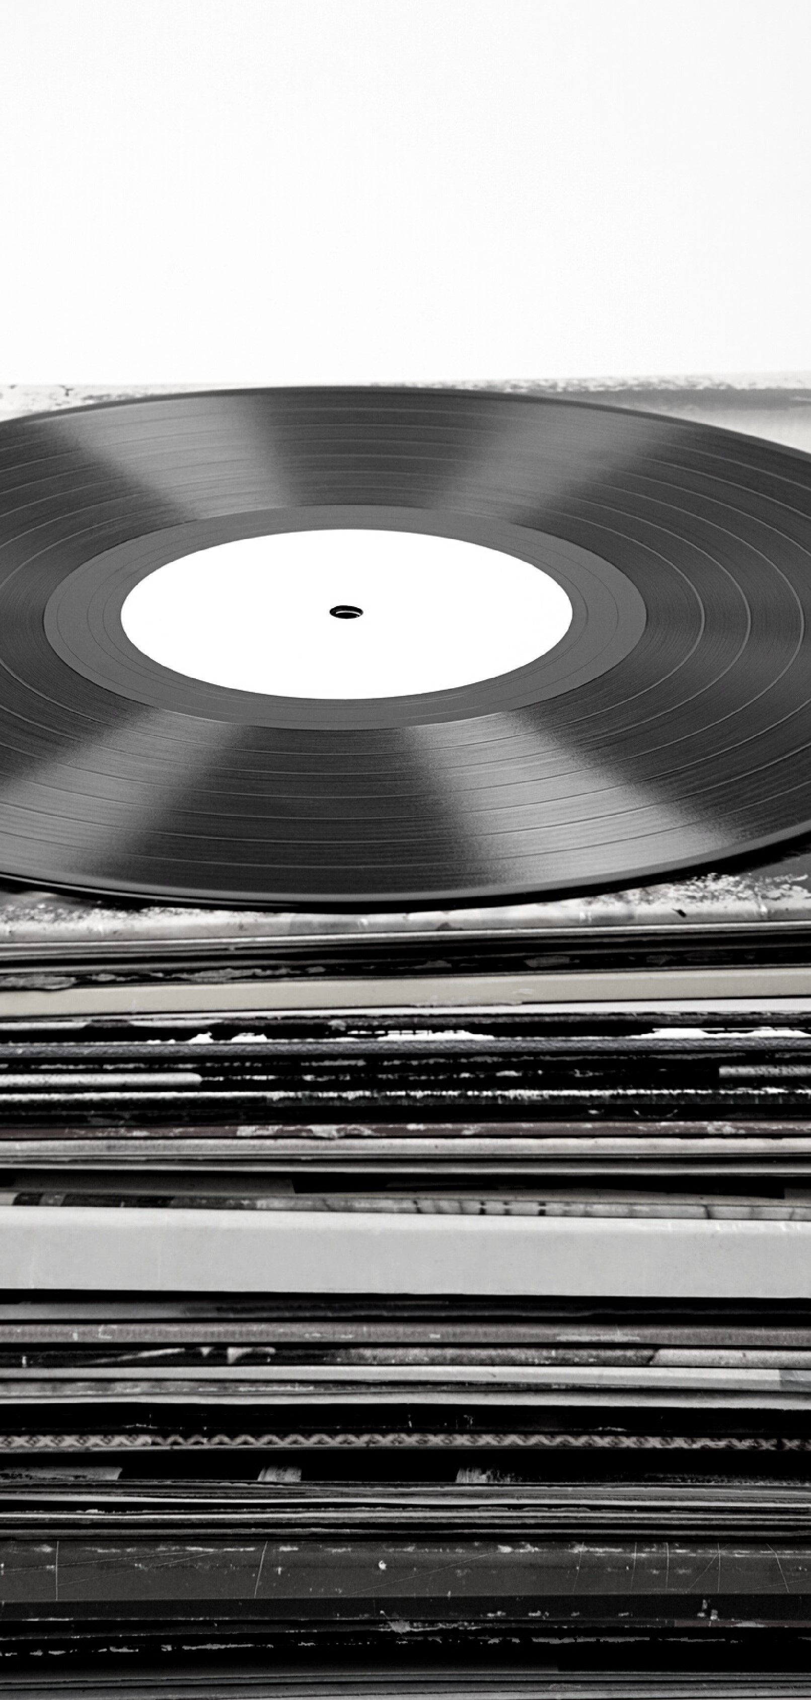
You MUST select a minimum of 6 songs.
For each song you select, you will provide context and explanation for the pairing of each song to the reading.
CLICK HERE for structure / outline
Resources / Inspiration
GOOGLE
Vulture - Best Movie Soundtracks
IMBD - List Best Soundtracks
Cosmpolatin - Soundtracks
INSTAGRAM
https://www.instagram.com/best_album_covers/

YOUTUBE
https://www.youtube.com/watch?v=dyIf_WfPrL4 https://www.youtube.com/watch?v=i19Y7HnW38U

